Perfect Rhyme (Exact Rhyme)

🔹 What is Perfect Rhyme (Exact Rhyme)
# Source: AI Source: Provided by: [Data Path: Persons Table -> ID Column: 1, Name_En Column: Motasem Essam] -> From: [Chatgpt (GPT-4-turbo)] on [8/1/2025]
A perfect rhyme (also called exact rhyme, full rhyme, or true rhyme) occurs when the final stressed syllables of two or more words match in both vowel and following consonant sounds.
The rhyme is complete in sound — everything from the last stressed vowel onward is identical in both words.

🧱 Structural Requirements
# Source: AI Source: Provided by: [Data Path: Persons Table -> ID Column: 1, Name_En Column: Motasem Essam] -> From: [Chatgpt (GPT-4-turbo)] on [8/1/2025]
A perfect rhyme must have:
- Matching vowel sound from the last stressed syllable.
- Matching consonant sound following the vowel.
- Different initial consonants (not identical words).

📝 Examples
# Source: AI Source: Provided by: [Data Path: Persons Table -> ID Column: 1, Name_En Column: Motasem Essam] -> From: [Chatgpt (GPT-4-turbo)] on [8/1/2025]
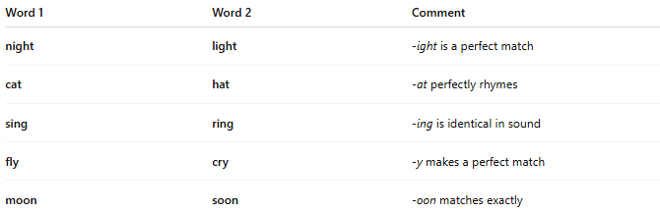
Word 1 | Word 2 | Comment
night | light | -ight is a perfect match
cat | hat | -at perfectly rhymes
sing | ring | -ing is identical in sound
fly | cry | -y makes a perfect match
moon | soon | -oon matches exactly

🔍 Types of Perfect Rhyme by Syllable Count
# Source: AI Source: Provided by: [Data Path: Persons Table -> ID Column: 1, Name_En Column: Motasem Essam] -> From: [Chatgpt (GPT-4-turbo)] on [8/1/2025]
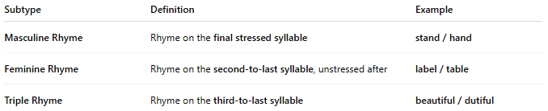
Subtype | Definition | Example
Masculine Rhyme | Rhyme on the final stressed syllable | stand / hand
Feminine Rhyme | Rhyme on the second-to-last syllable, unstressed after | label / table
Triple Rhyme | Rhyme on the third-to-last syllable | beautiful / dutiful

🎯 Used In
# Source: AI Source: Provided by: [Data Path: Persons Table -> ID Column: 1, Name_En Column: Motasem Essam] -> From: [Chatgpt (GPT-4-turbo)] on [8/1/2025]
- Traditional poetry (sonnets, ballads, limericks)
- Song lyrics
- Nursery rhymes
- Spoken word and rap

⚠️ Not to Be Confused With
# Source: AI Source: Provided by: [Data Path: Persons Table -> ID Column: 1, Name_En Column: Motasem Essam] -> From: [Chatgpt (GPT-4-turbo)] on [8/1/2025]
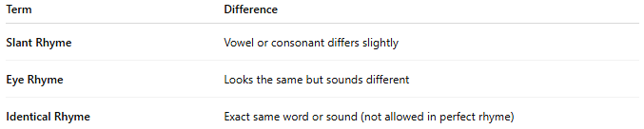
Term | Difference
Slant Rhyme | Vowel or consonant differs slightly
Eye Rhyme | Looks the same but sounds different
Identical Rhyme | Exact same word or sound (not allowed in perfect rhyme)

